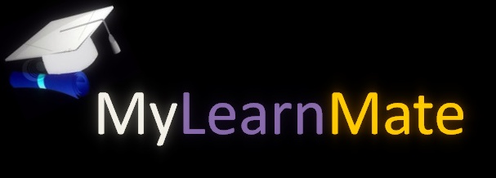

**Case study**

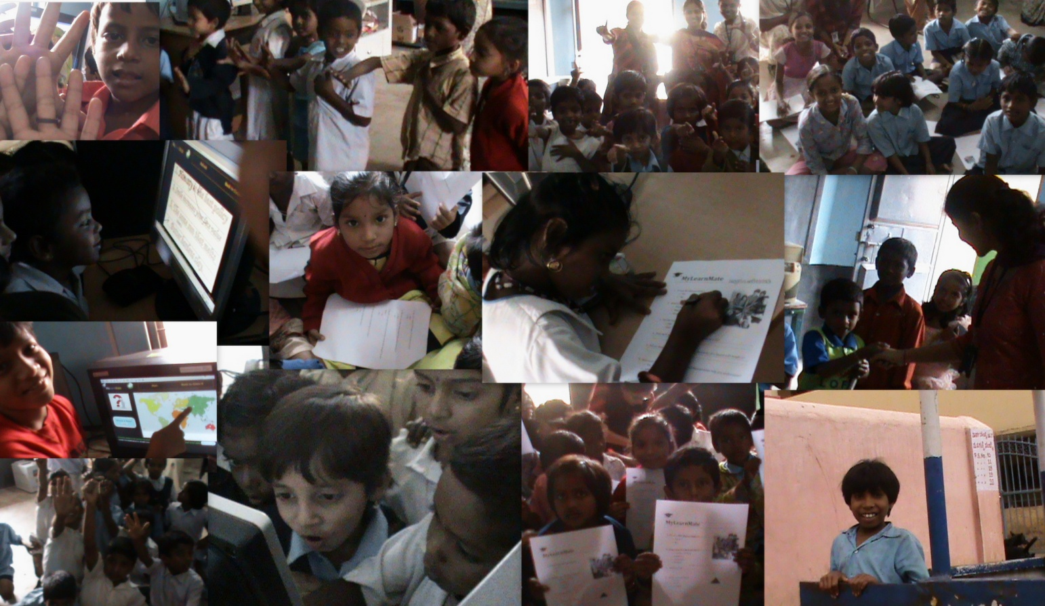



**Overview:**

As the growth of computers and technology advancing at this level, it raises the need to analyze what and how the teaching strategies should be followed and how these advances in technology should be made use of to incorporate a system of educational software.

**Summary:**

MyLearnMate is aimed at implementing the science and math concepts with interactivity uniquely provided by Microsoft ink, drag and drop, and touch for primary school students (children of 5-11 years of age).

**Situation:**

The main reason for the failure of present day educational systems is that the individual needs of each student to sustain a successful learning process are essentially ignored in traditional classroom practice. Transformations that purports to accelerate the solution of these problems requires the support of educational technology that improves learning outcomes and provides motivation to learn by making teaching and learning more interactive and fun, which can be achieved by using touch technology thus making learners more involved in the subject matter.

We wanted to see whether the activities of teaching mathematics and science designed by MyLearnMate using Silverlight and touch technology, allow the student of 5-10 years to build the key concepts of their curriculum, and develop qualitative thinking skill to answer the questions of mathematics and science.

**Solution:**

We based the design of these activities in studies realized by MyLearnMate workshop conducted at primary schools to get the response and feedback from teachers and researchers who have worked these topics, such as researchers in the science, mathematics, computation and educational technology.



Workshop conducted at the Government Model Primary School and Anatha Shishu Nivas had the following feedback about MyLearnMate from teachers:

1. Mrs.R.K.Indira coated that “MyLearnMate is a very good program; it works as a friendly tool for the students by making their process of learning easy and fun.”
2. Ms.Manjula, coated that the “Today’s session was excellent, MyLearnMate is a very nice tool to develop some basic concepts in pupils, such tools help the student skills to work with computers.”

The students also showed great interest in working with the touch interfaces of the computer system and had autonomy in the resolution of tasks.

The following chart shows the student response for the questions to solve maths and science problems after practicing through MyLearnMate.

From the student results, we can say that the activities designed to support education, are best imparted with practical examples and methods for the student in the consolidation of the various essential and key academic concepts and skills using MyLearnMate.

Thus, the meta-analysis conducted on elementary school students in India reported that computer-based MyLearnMate education through the use of touch technology has generally had positive effects on the achievement of elementary school students.

* On average, about 80% of the students could perform arithmetic operations faster after practicing through these computer systems.
* Students could learn more in less time when they received computer-based instruction and when they had to answer just by touch.
* Maximized student reflection and encouraged progressive taught, taking multiple perspectives, and independent thinking.
* Students who practiced geometry and other scientific concepts through the touch based interactive computer system showed better problem solving skills than students who learnt concepts and definitions through classroom instructions only.

**Contact**

**C:\Users\sneha\Desktop\Untitled.jpg**

**C:\Users\sneha\Desktop\1.jpg** [**www.dataminingtools.net/contact.php**](http://www.dataminingtools.net/contact.php)

**C:\Users\sneha\Desktop\11.jpg** [support@dataminingtools.net](mailto:support@dataminingtools.net)

**About us**

MyLearnMate is aimed at implementing the science and math concepts for students from first grade to fifth grade (children of 5-11 years of age) through an easy interactive mechanism using Ink, Drag and Drop and Touch interfaces.

MyLearnMate enhances the learning experience of the student and take them beyond classroom to learn the science and math concepts the fun way.

In case of suggestion or feedback, please write to us at: support@dataminingtools.net